**Name:** Mostafa Abdallah Mohamed Said

**B.N:** 916

**Date:**

**Topic:** Data base systems

**GitHub link:**

**GitHub page (published-website):**

**Application Brief:** I have chosen Data base management systems as a main topic because it is important and has lots of uses and applications in many aspects in our life. As it accepts the request for data from an application and instructs the operating system to provide the specific data, it allows users to create their own databases as per their requirement. It has many applications in many different sectors such as banking, airlines, universities, sales, manufacturing and many other sectors in society. I have also chosen it because it has many advantages as it offers a variety of techniques to store and retrieve data, it offers data integrity and security, and many other advantages.

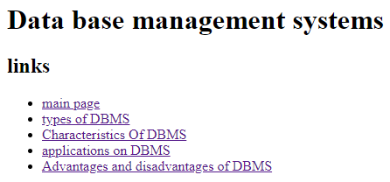**Screenshots:**

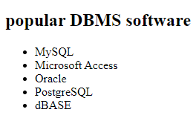

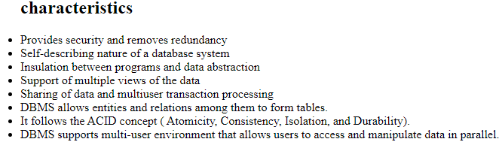



**Source code:**

